**Department of Computer Science**

Project Proposal Summer 24-25

|  |  |  |  |  |  |
| --- | --- | --- | --- | --- | --- |
| Course Title | WEB TECHNOLOGIES | Section | F | #Group | 9 |

**Group Member**

|  |  |  |
| --- | --- | --- |
| Student ID | Name | Signature |
| 22-49842-3 | MD NAIMURE RAHAMAN EMON |  |
| 22-49311-3 | MD. MOSADDEK MUTTAKEY |  |

**Project Title:**

|  |
| --- |
| Library Management System |

**Short Description:** The Library Management System is a web-based application that enables students and librarian to efficiently manage library resources. Students can browse, borrow, and return books, while librarian users can manage the book catalog and monitor transactions. The system provides authentication, personalized dashboards, and profile management for all users.

|  |
| --- |
| **Type of user: 1. Student, 2. Librarian**  **Common Features (Available to All Users)**   * **Authentication**  1. Login to the system 2. Logout from the system 3. User registration  * **Account Management**  1. Change or reset password 2. Manage profile information (view, edit, delete)  * **Dashboard**  1. Home dashboard 2. Access a personalized dashboard after login   **Specific Features by User Type**   * **Features of Student**  1. Browse book catalog 2. Search for books by title/author/category 3. Borrow a book 4. Cancel a borrow request 5. Return a borrowed book 6. View borrowing history  * **Features of Librarian**  1. Add new book 2. Edit book details (title, author, availability) 3. Delete a book from the catalog 4. View all borrowed books list 5. Approve/decline borrow requests 6. Post announcements (notice board) |

**Use Case Diagram: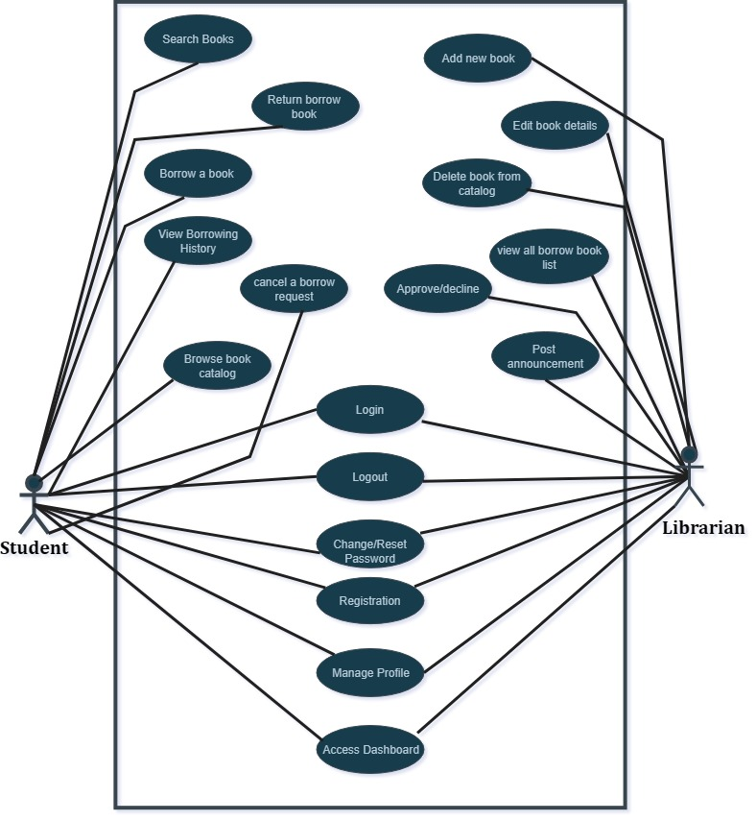 Class Diagram: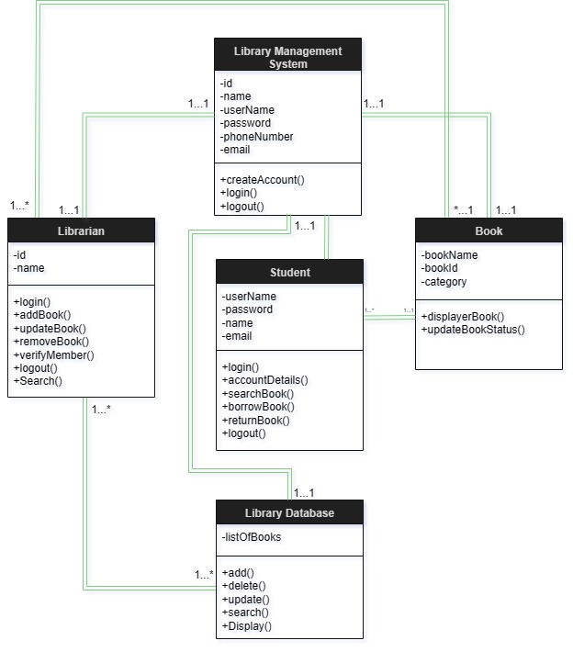 Activity Diagram: 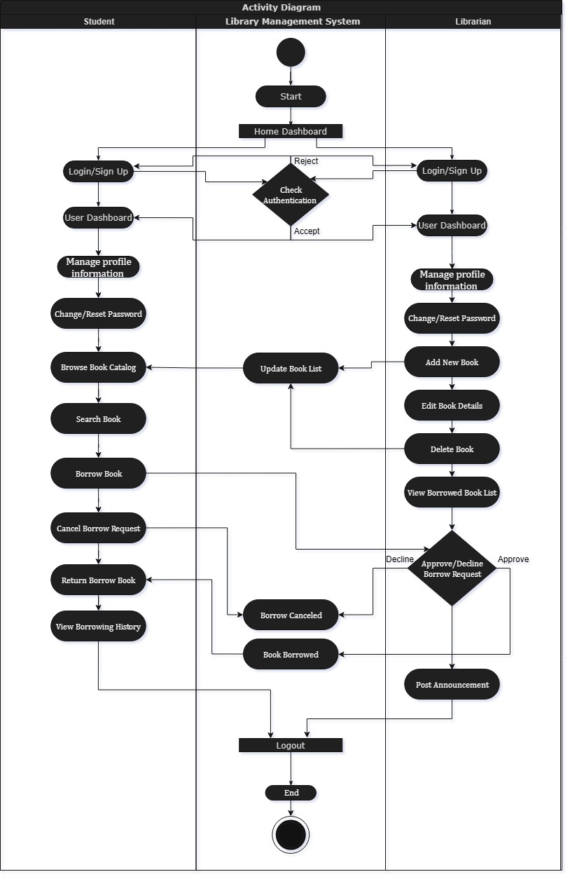 Login Page:  
  
